

Neural Networks



Course: ALY 6020 Predictive Analytics

Instructor: Dr. Marco Montes de Oca

Submitted by: Nithish Saravanan

Neural Networks can be categorized into feedforward neural networks and recurrent neural networks. These algorithms are used to model and recognize patterns.

MNIST dataset consists of two datasets for training and testing which are said to be handwritten digits given by thousands of user to seven segment display representation.

The necessary packages are imported into the python environment.

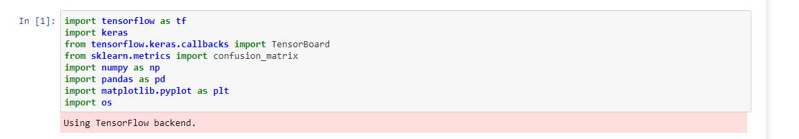

The next step is reading the data set from two different files that are provided.

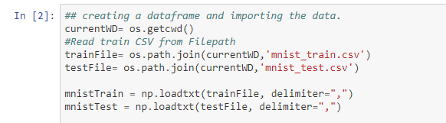

Further we will split the dataset into x_train, y_train, x_test and y_test

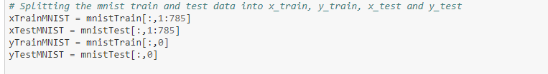

Now the digit is plotted in the pixels

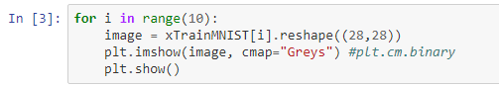

This gives the following output:

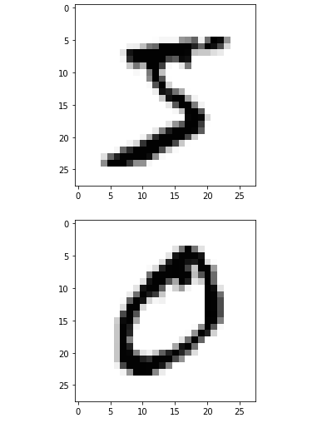

Now the model with softmax layer to check the fit of model.

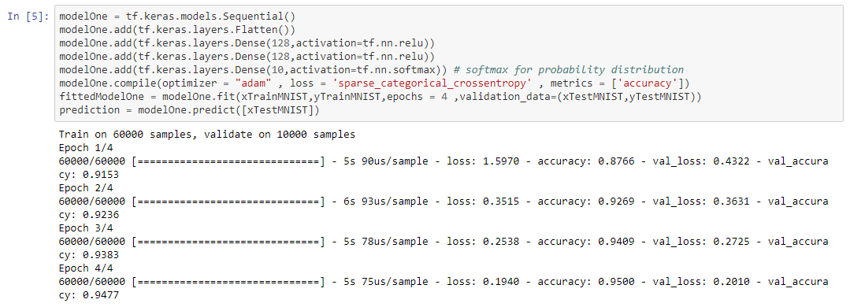

This gives the loss and accuracy of the model that is being created.

Seven segment representation of digits needs binary values for each segment to be switched on so let us represent the segments as 1’s and 0’s. Where 1’s are said to be segment ON and 0’s for segment OFF.

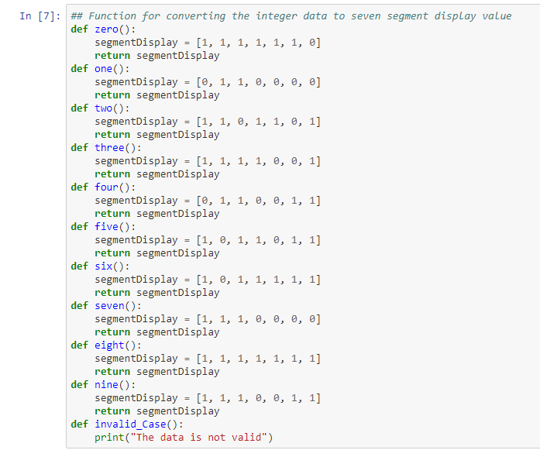

Two loops are created to iterate the values and check based upon the segment values. Here one loop is done for training dataset and other for test dataset.

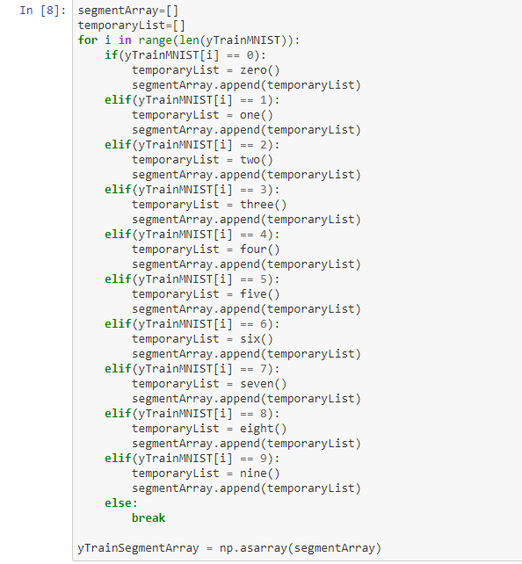

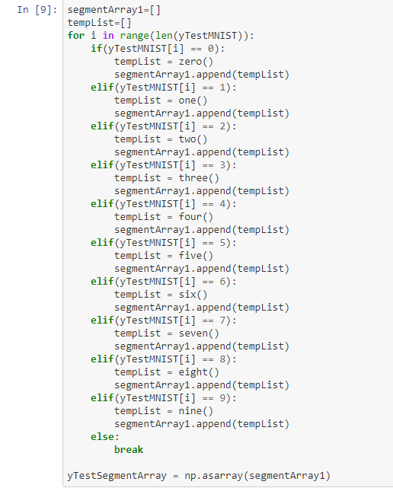

With the training segment array and test segment array we can create a model with sigmoid.

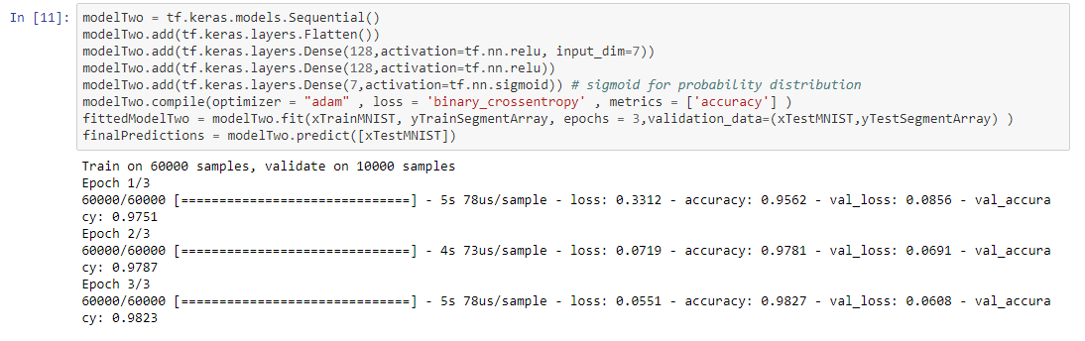

Now we will create confusion matrix to check the seven segment accuracy.

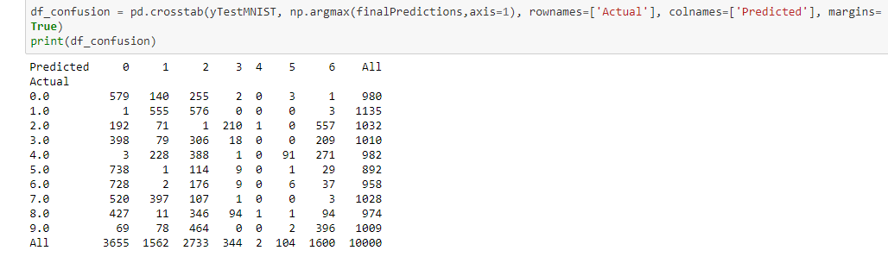

Considering the two models it took 4 epochs for model with softmax to get 95% accuracy for the given data set. The same with 3 epochs gave 98% accuracy with sigmoid. Thus, we can say that digit recognition can be more accurate with sigmoid that softmax.